
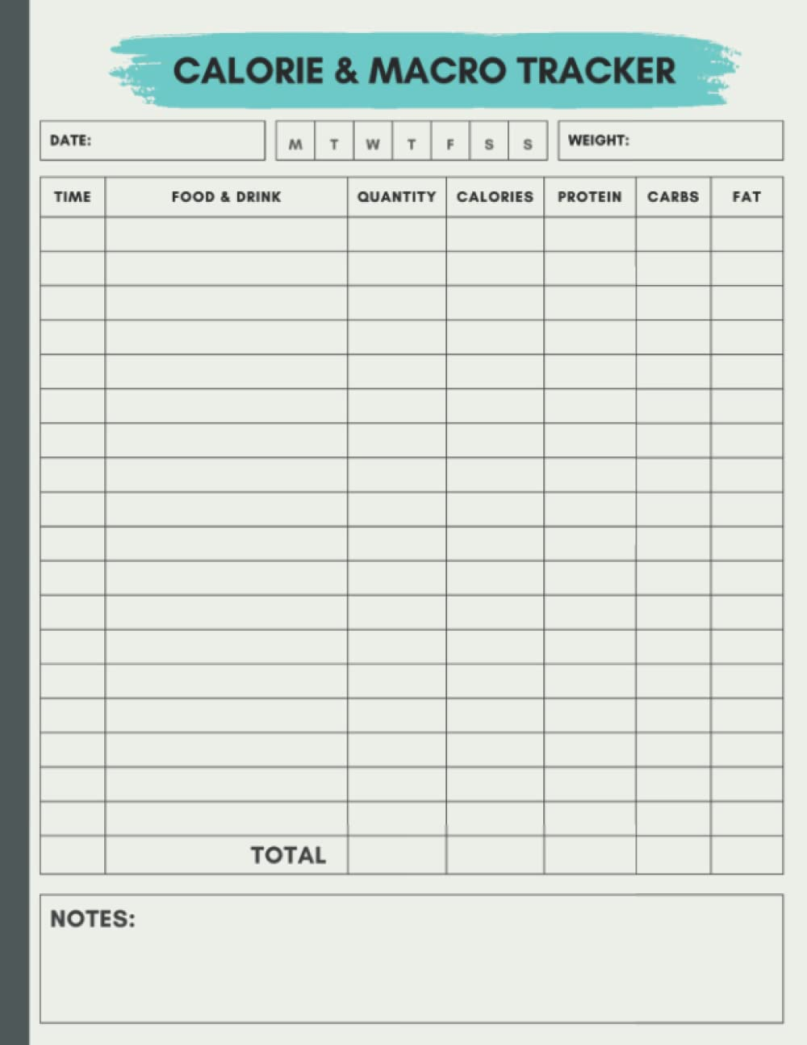
*Tracking is best done on the free version of the MyFitnessPal app, but this document can also be used if that is not an option for you.

